**Assessment – Output Document**

**Author: Prathyusha Kochuru**

**Date: 02/26/2021**

**Tool used: Eclipse**

**Project – LockedMe.com**

* **Welcome screen & Main menu**

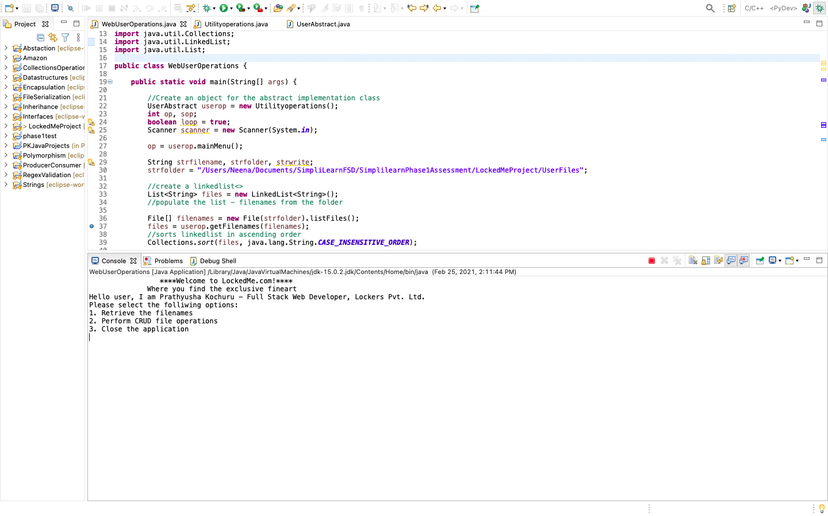

* **Option 1 – Retrieve all the filenames in a directory – traversing through all the subfolders**

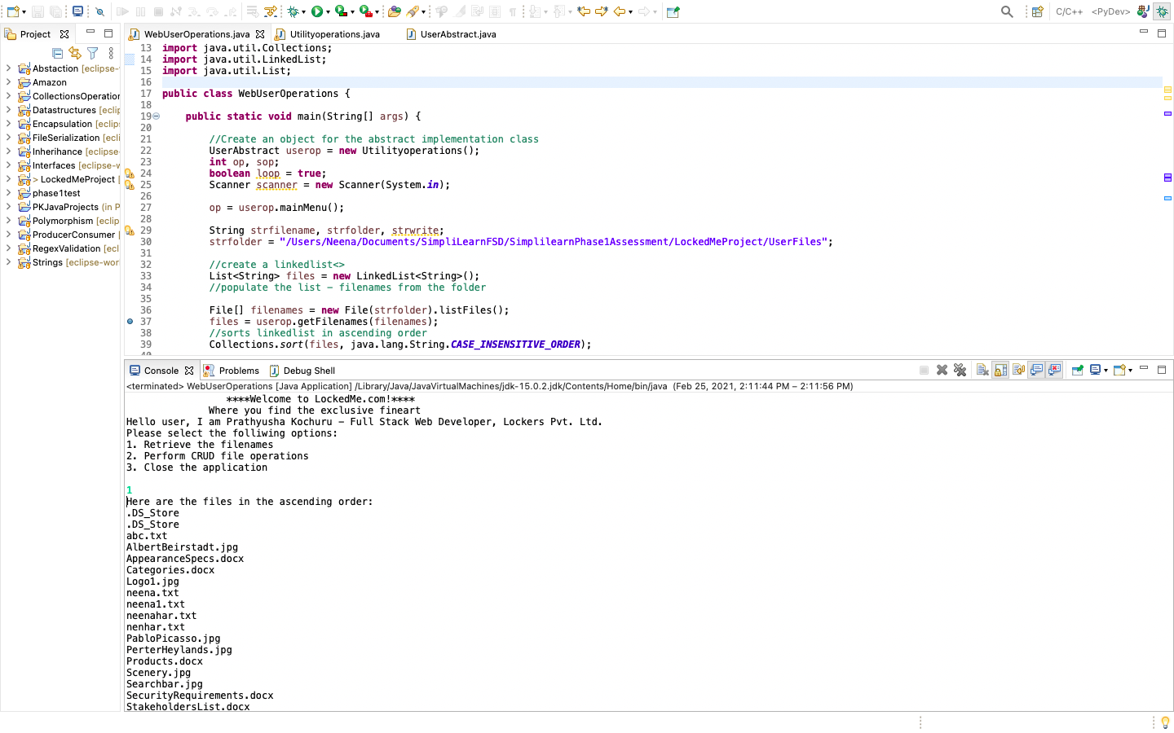

* **Option 2 – Second menu – Perform CRUD on User files**

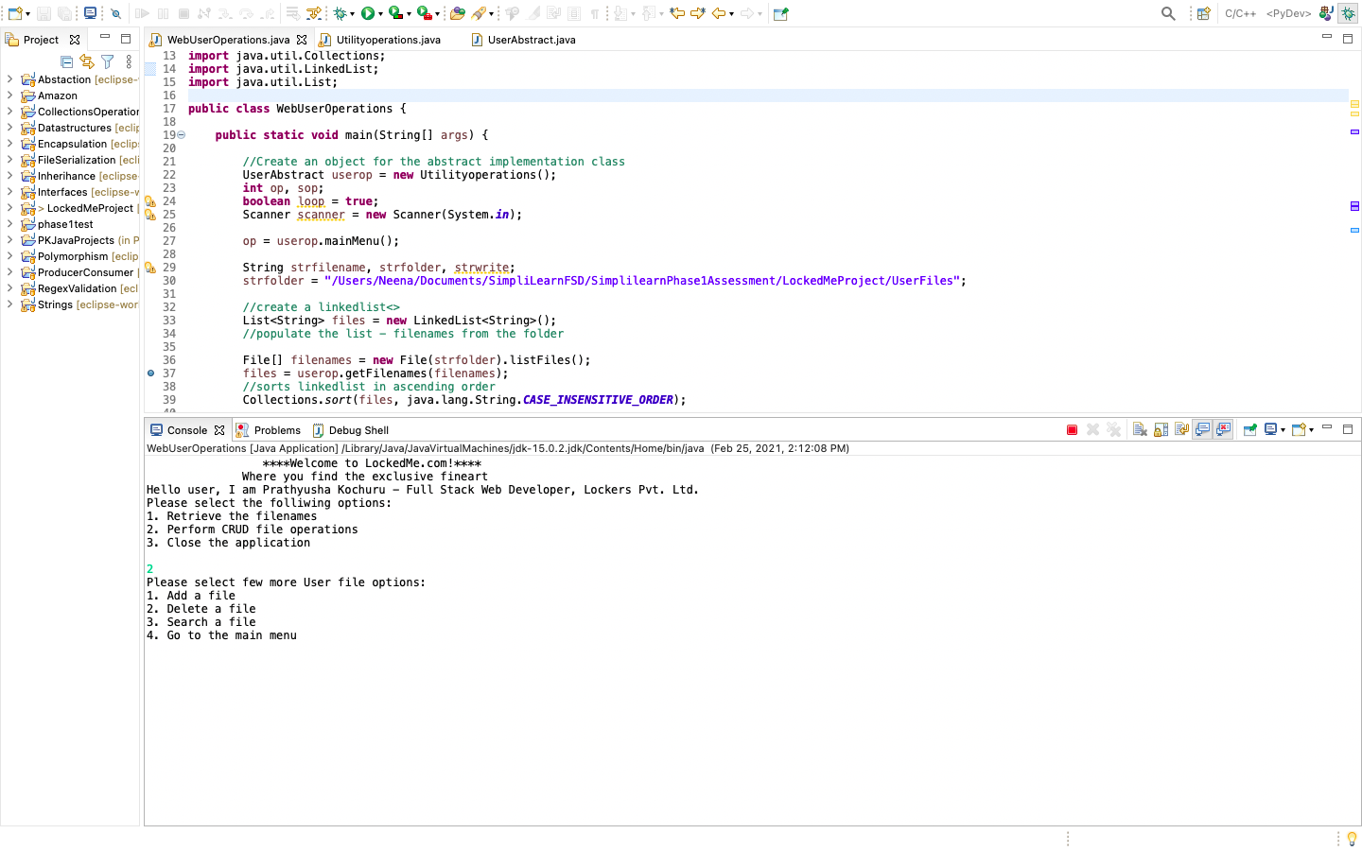

* **Sub menu – Option 1 – Add a new file**

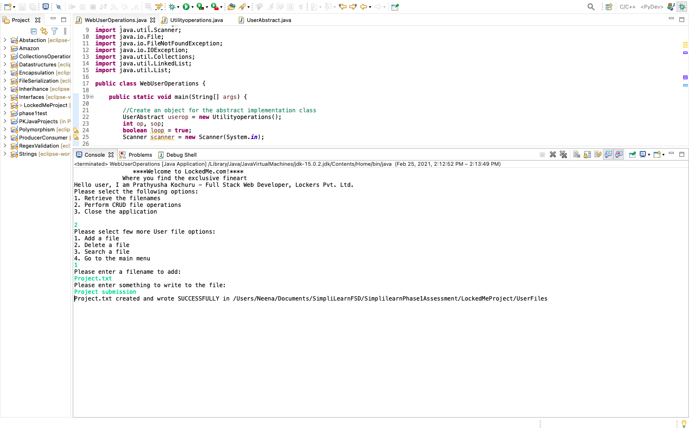

**Checks for the file exists and display a message if trying to add an existing file.**

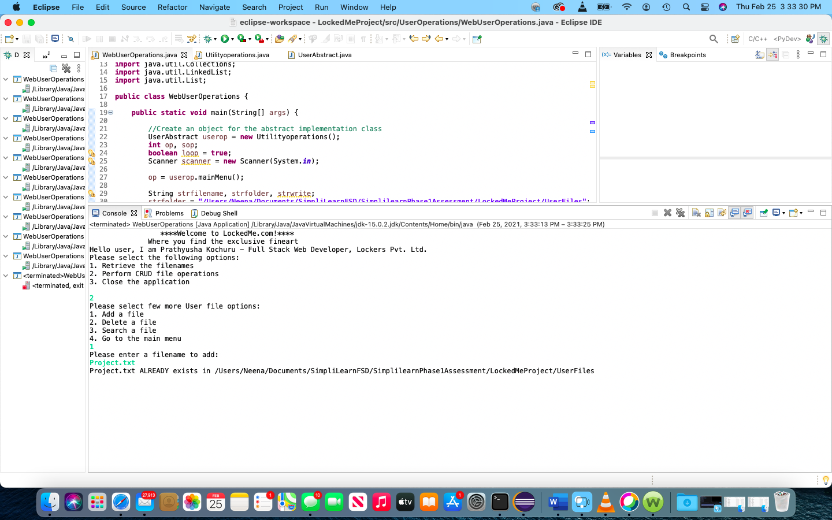

* **Sub menu – Option 2 – Delete a file with case sensitive (correct file should be deleted)**

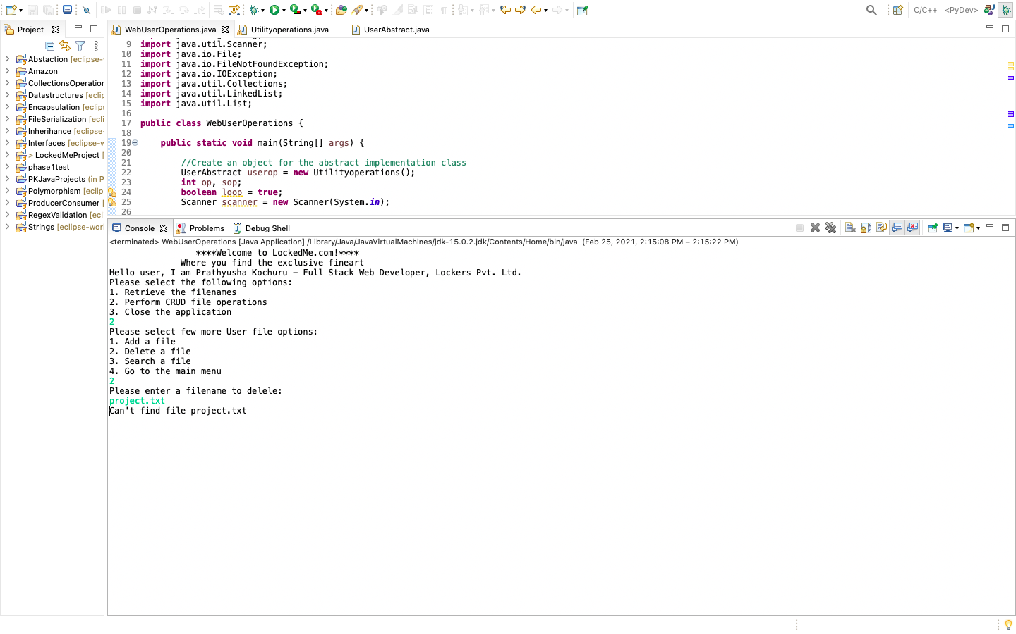

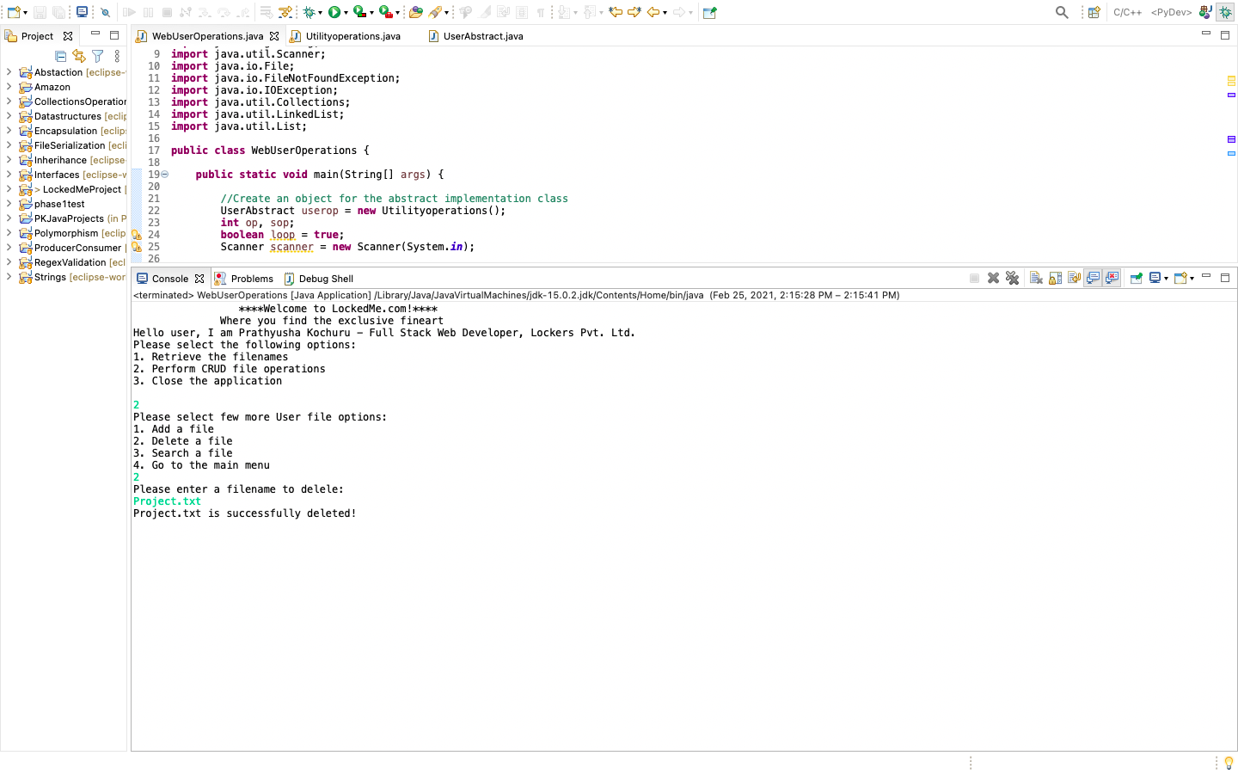

* **Sub menu – Option 3 – Search for a file – with case sensitive**

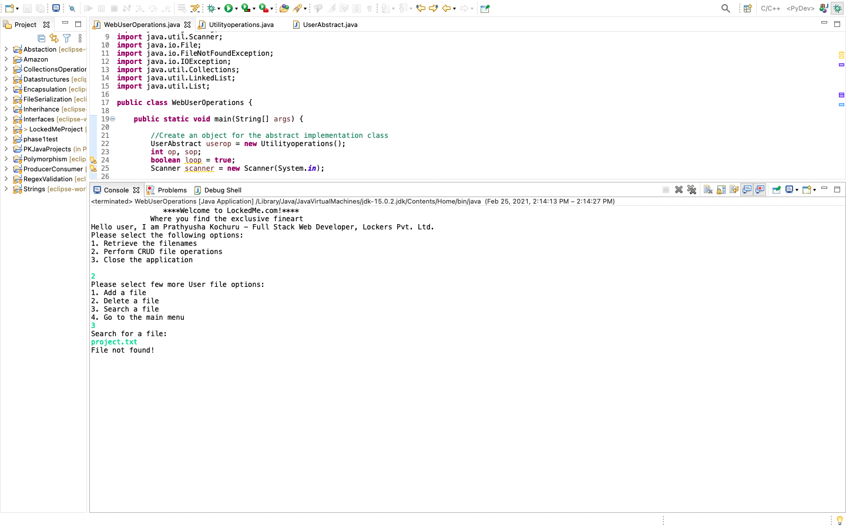

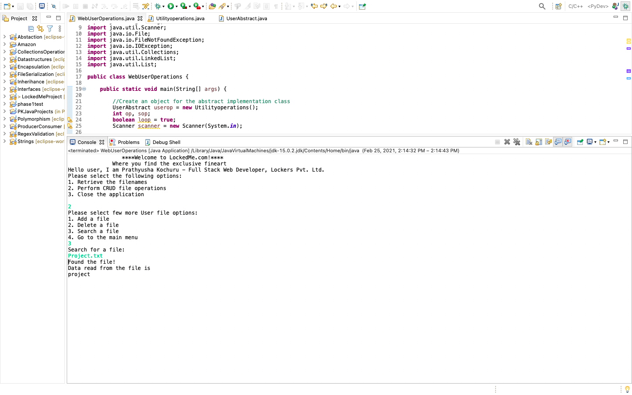

* **Sub menu – Option 4 – Go to the main menu**

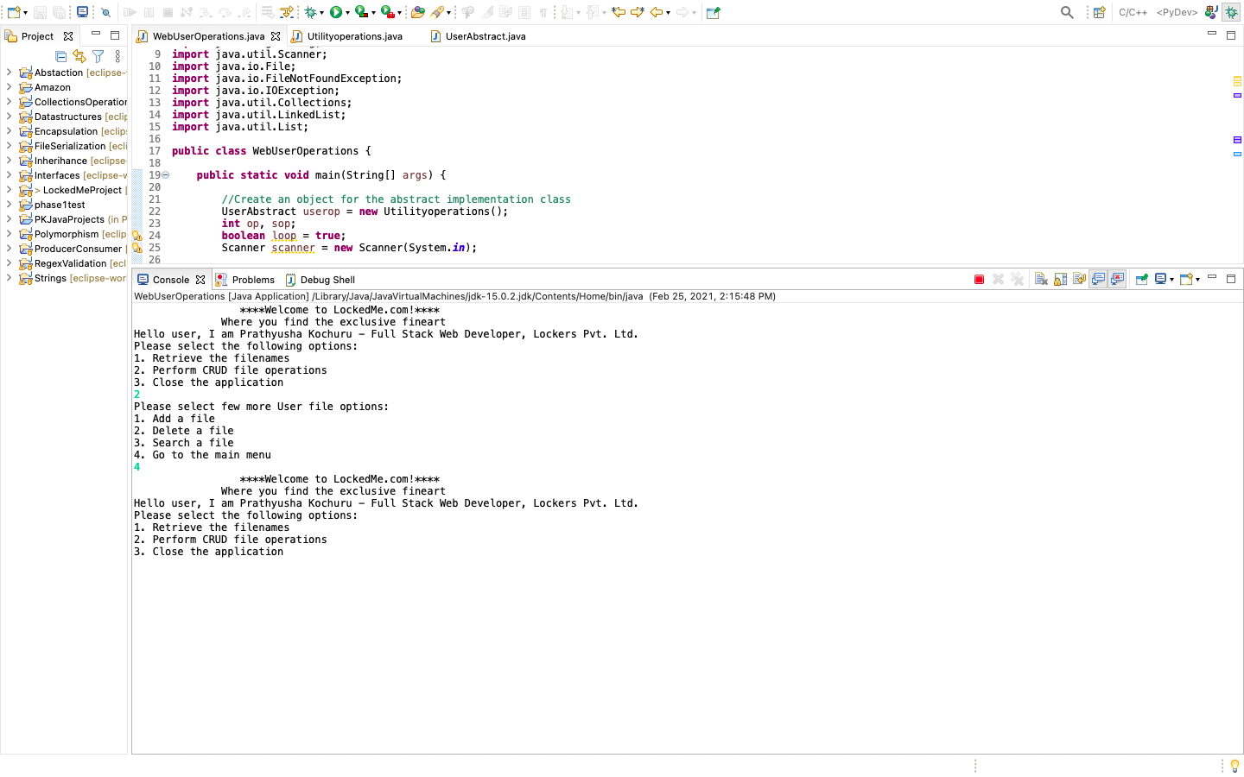

* **Option 3 – Close the application**

